**RUSSIAN CONTENT DEVELOPMENT PLAN FOR THE CONTRACT № XXXXX BETWEEN XXX AND SAKHALIN ENERGY LLC**

|  |  |  |  |  |
| --- | --- | --- | --- | --- |
| **APPROVED BY** | **POSITION** | **NAME** | **SIGNATURE** | **DATE** |
| **ON CONTRACTOR’S BEHALF** |  |  |  |  |
| **ON COMPANY’S BEHALF** |  |  |  |  |

# Objective

Sakhalin Energy LLC (hereinafter – Company, Sakhalin Energy) will use its best efforts to maximize the Russian content in each year and to achieve a level of Russian content (hereinafter - RC) (including labor, materials, equipment and contract services) of seventy percent (70%) over the life of the entire Sakhalin Project, subject to Russian enterprises meeting the price, quality and timing of delivery requirements based on Production Sharing Agreement[1] (“PSA”).

Therefore, the Company requires its subcontractors and suppliers to use its best efforts to maximize utilization of Russian industrial and human resources in any ensuing contract following submission of proposed RC and Russian industry Utilization Plan (RC and RIU Plan) as part of their tender documentation and any ensuing contract.

The aim the RC Development Plan ((hereinafter – RCDP, Plan) is to determine RC targets and control over implementation of measures to maximise RC during the contract execution.

The RCDP is defining the following:

* Contractor's company structure (i.e. whether OAO, ZAO, OOO, sole proprietorship or joint venture);
* RC Targets to be achieved by the Contractor during the performance of the scope of work under the Contract;
* Resources, methods, practices and procedures to be used by the Contractor to achieve those targets;
* RC reporting requirements, incl.:
  + - Report on the employment in connection with the Project;
    - RC report attached to invoice.

The Plan is subject to review (if required) and change (if agreed with the Company) during the term of the Contract. Changes in the RCDP may be caused by alterations in Contract terms, the scope of work or other contractual obligations, as well as by changes in market situation and emergence of new opportunities to increase the RC.

Details on Russian content requirement can be found in the **Sakhalin-II PSA. Russian Content. General Guideline for Contractors**, available at the Company web-site [http://www.sakhalinenergy.ru](http://www.sakhalinenergy.ru/) (Section “Contracting with us” – “Russian Content” – “General guidelines for contractors”).

# introduction

*Please indicate which Contract this plan is a part of, scope of work for the Contract, what is Contractor’s strategy about achieving the declared targets etс.*

# contractor’s company structure

*Please indicate year of Company foundation, Company legal form (OAO, ZAO, JV etc), country and town of registration, list of main Shareholders.*

# RUSSIAN EXPENDITURE

*Please indicate which payments are included into the expenditures (the examples of the possible types of payments that can be included into expenditures can be found in section 3.7 Sakhalin-II PSA. Russian Content. General Guideline for Contractors (*available at the Company web-site [http://www.sakhalinenergy.ru](http://www.sakhalinenergy.ru/en/index.wbp) (Section “Contracting with us” – “Russian Content” – “General guidelines for contractors”).

*Please include yearly Russian labour and industry involvement targets with the Russian expenditure assessed according to the Table 1 below:*

*Table 1:*

|  |  |  |  |  |  |
| --- | --- | --- | --- | --- | --- |
| Year | Total planned contract value, contract currency | Planned Russian expenditure, contract currency | Target share of planned Russian expenditure in the total planned contract value, % | Planned foreign expenditure, contract currency | Share of planned foreign expenditure in the total planned contract value, % |
| 1 | 2 | 3 | 4 = (3) / (2) | 5 | 6 = (5) / (2) |
| Year 1 |  |  |  |  |  |
| Year 2 |  |  |  |  |  |
| Year 3 |  |  |  |  |  |
| Year х |  |  |  |  |  |
| Year x |  |  |  |  |  |

# utilisation of russian labour resources

## Russian personnel %

*Please indicate yearly Russian personnel targets as per Table 2 below:*

*Table 2*

|  |  |  |  |  |  |
| --- | --- | --- | --- | --- | --- |
| Year | Total planned number of personnel utilised for work under the contract, staffing positions (persons) | Planned number of Russian personnel utilised for work under the contract, staffing positions (persons) | Share of Russian personnel, % | Planned number of Foreign personnel utilised for work under the contract, staffing positions (persons) | Share of foreign personnel, % |
| 1 | 2 | 3 | 4 = (3) / (2) | 5 | 6 = (5) / (2) |
| Year 1 |  |  |  |  |  |
| Year 2 |  |  |  |  |  |
| Year 3 |  |  |  |  |  |
| Year х |  |  |  |  |  |
| Year x |  |  |  |  |  |

## Russian man-hours %

*Please indicate yearly Russian labour utilization targets as per Table 3 below:*

*Table 3*

|  |  |  |  |  |  |
| --- | --- | --- | --- | --- | --- |
| Year | Total planned number of (Russian and foreign) man-hours | Planned number of Russian man-hours | Target percentage of Russian labour utilization, % | Planned number of foreign man-hours | Percentage of foreign labour utilization, % |
| 1 | 2 | 3 | 4 = (3) / (2) | 5 | 6 = (5) / (2) |
| Year 1 |  |  |  |  |  |
| Year 2 |  |  |  |  |  |
| Year 3 |  |  |  |  |  |
| Year х |  |  |  |  |  |
| Year x |  |  |  |  |  |

*Please provide the list of resources and procedures that enable to achieve the values declared:*

* *split of Russian vs. foreign employees as per the following positions: office and management personnel, HSE, engineering and technical positions, other;*
* *plan of replacement of foreign personnel by qualifies Russian staff;*
* *employment policy;*
* *access to local and mainland Russia competent labor resources;*
* *personnel training and development plan including the list of planning activities, schedule, number of personnel, training resources to be used, description of personnel competence assessment system.*

# RUSSIAN MATERIALS AND EQUIPMENT

*Please indicate yearly Russian materials and equipment targets as per Table 4 below:*

*Table 4*

|  |  |  |  |  |  |
| --- | --- | --- | --- | --- | --- |
| Year | Total planned weight of goods, materials and equipment, kg | Planned weight of goods, materials and equipment which are Russian, kg | Target percentage of Russian materials and equipment, % | Planned weight of goods, materials and equipment which are foreign, kg | Target percentage of foreign materials and equipment, % |
| 1 | 2 | 3 | 4 = (3) / (2) | 5 | 6 = (5) / (2) |
| Year 1 |  |  |  |  |  |
| Year 2 |  |  |  |  |  |
| Year 3 |  |  |  |  |  |
| Year х |  |  |  |  |  |
| Year x |  |  |  |  |  |

*Please provide the list of resources, practices and procedures that enable to achieve the values declared:*

* *list of production facilities located on the Russian territory and planned to be employed for supplying the Company as per contract;*
* *list of materials and equipment including the proposed source of materials (Russian or foreign);*
* *list of potential Russian suppliers;*
* *Import replacement Program;*
* *local supply chain development/vendor development — a plan of domestic production of the required equipment, accessories, spare parts, standard components, assembly, etc.*

# Subcontracting of Services/ Works

*Please specify monetary (in contract currency) and/or relative (percentage of total contract value) Russian Content targets in planned direct subcontracts.*

*If participation of subcontractors is direct (required for execution of the contract scope), the Russian labour and volume of materials to be submitted by subcontractors should be included in the labour and material targets in sections 4, 5 and 6 above.*

*Please provide the list of the following resources, actions and procedures that enable to achieve the targets:*

* *the list of works to be subcontracted indicating the list of potential subcontractors for each type of such works;*
* *the policy and the procedures of subcontract awarding and subcontractors selection principles.*

# Report on the employment IN CONNECTION WITH THE PROJECT

Following the Company’s request, the Contractor shall submit quarterly Report on the employment in connection with the Project to the Company’s Russian Content Reporting Specialist by e-mail to [**sellc-vendor-reporting@sakhalin2.ru**](mailto:seic-vendor-reporting@sakhalinenergy.ru)using the following template:



**\*** The Report shall be submitted by the Contractor to the Company in Excel format, only the grey fields shall be filled in.

In addition, the Contractor shall submit information on forecasted personnel for each year until contract expiry date upon request from the Company.

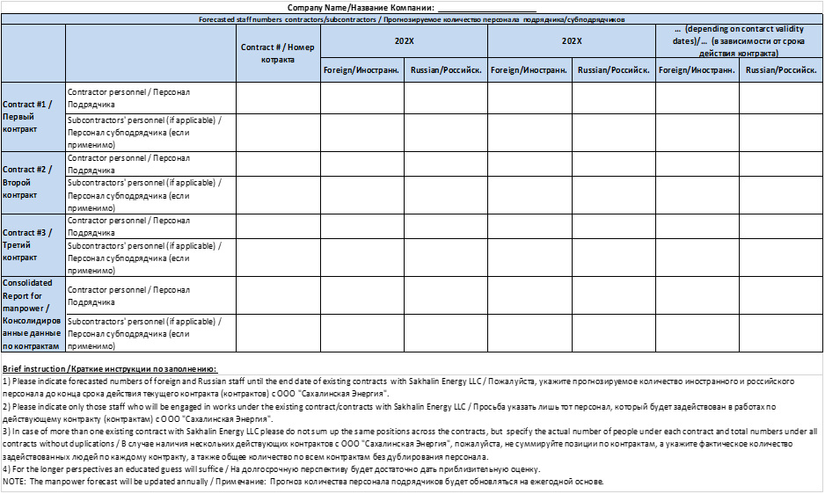

# rC report attached to invoice

Under the PSA provisions, the Russian Content is measured on an overall quantity basis, i.e. volume of materials and equipment (expressed in weight), man-hours of services and works, as well as in monetary terms.

In an attachment (“RC Report”) to each invoice for the Company, Contractor shall provide actual RC performance information in the form of the RC Report specified in **Appendix A** hereto. RC Reports are required even if the actual RC is nil in order to allow for calculation of RC as a percentage of the total man-hours and weight of equipment and materials utilised in the Sakhalin-2 Project. If the Contractor forms RC reports automatically, using information systems, slight deviations from the template are allowed, though the following shall be maintained:

* report header: name, reference number, and date of the invoice, the Contractor’s name;
* structure of indicators, their sequence, and signs. The names can be in one language only (Russian or English); and
* contact information and signature of the person responsible for the report.

The RC Report shall be signed by the responsible person.

The Contractor shall submit the RC Report as an attachment to every invoice for a work conducted for the Company. Failure to provide such an attachment, its improper execution, or provision of incorrect data in the RC Report may serve as a reason for refusal to pay the invoice until the errors are corrected. If any inaccuracies in the provided data are discovered, the attachment should be resubmitted, or further calculations should be corrected in order to obtain accurate consolidated RC figures per the contract.

The Contractor shall include suitable equivalent RC Reporting clauses in subcontracts in order to ensure provision of RC data from the subcontractors of all levels. If any subcontractor does not provide RC Reports, contractor should prepare estimation for RC numbers for this subcontractor with maximum possible data accuracy and include this estimation in its overall RC Report submitted to the Company. If estimates are used to form the RC Report, the Contractor shall be obliged to inform the Company about it and about the methods used to calculate and check such estimates.

Sakhalin Energy shall have the right to audit the correctness of the Contractor’s generation of RC Reports. During an RC audit, the Company shall request the Contractor to provide it with the procedure used to create the RC reports (local regulations or process description) and supporting primary documents for the RC Reports that have been submitted to the Company in order to compare the provided data with the actual ones. Following the results of the RC audit, the Company shall check the quality of the submitted data and, if any problems are discovered, jointly with the Contractor develop a plan to eliminate them.

# Appendix A Contractor russian content report form

RUSSIAN CONTENT REPORT

ОТЧЕТ ПО РОССИЙСКОМУ УЧАСТИЮ

**Attachment to Invoice # /Приложение к Счету № _____________ dated /от __________**

**Contract № (or PO №) / Договор № (или Заказ №):**

**Company Name / Название компании:**

**Table 1: Monetary value**

**Таблица 1: Стоимость**

|  |  |  |
| --- | --- | --- |
|  | **Description / Наименование** | **Value / Значение** |
| 1 | The total value of this invoice IN INVOICE CURRENCY (EXCLUDING VAT) Общая сумма счета В ВАЛЮТЕ СЧЕТА (ИСКЛЮЧАЯ НДС) |  |
| 2 | The Russian expenditure related to this invoice IN INVOICE CURRENCY (EXCLUDING VAT) Российские расходы, отраженные в данном счете В ВАЛЮТЕ СЧЕТА (ИСКЛЮЧАЯ НДС) |  |

**Table 2: Labour**

**Таблица 2: Трудозатраты**

|  |  |  |
| --- | --- | --- |
|  | **Description / Наименование** | **Value / Значение** |
| 1 | The total labour related to this invoice IN MAN-HOURS Общие трудозатраты по данному счету В ЧЕЛОВЕКО-ЧАСАХ |  |
| 2 | The Russian citizens labour related to this invoice IN MAN-HOURS Трудозатраты граждан России по данному счету В ЧЕЛОВЕКО-ЧАСАХ |  |

**Table 3: Goods, materials and equipment**

**Таблица 3: Товары, материалы и оборудование**

|  |  |  |  |
| --- | --- | --- | --- |
|  | **Description / Наименование** | | **Value / Значение** |
| 1 | The total weight of goods, materials and equipment related to this invoice IN KILOGRAMS Общий вес товаров, материалов и оборудования по данному счету В КИЛОГРАММАХ | |  |
| 2 | The weight of Russian goods, materials and equipment, related to this invoice IN KILOGRAMS Вес товаров, материалов и оборудования российского происхождения по данному счёту В КИЛОГРАММАХ | |  |
| **Person responsible for this report**  **Ответственный за данный отчет** | | | _____________________________________  Name / ФИО  ____________________________________  Contact details (tel, email)  Контактная информация (тел, электр. адрес) | | |

***Notes / Примечания:***

*1/ Monetary and physical values shall be shown in the second column. Currency shall be shown together with monetary values.*

*Стоимостные и физические показатели указываются во второй колонке. Вместе со стоимостными показателями необходимо приводить символ либо краткое наименование валюты.*

*2/ For defining of what is related to “Russian expenditure”, “The Russian citizens labour”, “The weight of Russian goods, materials and equipment”, please refer to* [*“Sakhalin-II PSA. Russian Content. General Guideline for Contractors”*](http://www.sakhalinenergy.ru/media/user/inform/General_Guideline_for_Contractors_Eng.pdf) *(№ 1000-S-90-01-M-0051-00-E).*

*Для определения показателей «Российские расходы», «Трудозатраты граждан России», «*Вес товаров, материалов и оборудования российского происхождения*», пожалуйста, обращайтесь к документу* [*«СРП по проекту «Сахалин-2». Российское участие. Рекомендации для подрядчиков»*](http://www.sakhalinenergy.ru/media/user/inform/General_Guideline_for_Contractors_Rus.pdf) ***(№ 1000-S-90-01-M-0051-00-R).***

***3/*** *If services rendered during the period the invoice is made out for do not contain Russian man-hours, goods, materials or equipment; Russian Content Report shall nevertheless be filled out with an indication of the total value of invoice.*

*Если по услугам, предоставленным в течение периода, за который выставлен счет, Российского участия не было, отчет по российскому участию, тем не менее, должен быть заполнен с указанием суммы счета и приложен к счету.*

***4/*** *Should you have any questions related to this report, or should you need an electronic version of Russian Content report template, please contact Russian Content Reporting Specialist by e-mail:* [sellc-vendor-reporting@sakhalin2.ru](mailto:seic-vendor-reporting@sakhalinenergy.ru)

*В случае возникновения вопросов в отношении составления отчета по российскому участию или необходимости получить электронную версию формы Отчета по российскому участию, просим обращаться к специалисту по подготовке отчетности о российском участии по e-mail:* [sellc-vendor-reporting@sakhalin2.ru](mailto:seic-vendor-reporting@sakhalinenergy.ru)

1. The Agreement on the Development of the Piltun-Astokhskoye and Lunskoye Oil and Gas Fields on the Basis of Production Sharing dated June 22, 1994 between Company and the Russian Federation